1-Create a ReplicaSet using the below yaml

apiVersion: apps/v1
kind: ReplicaSet
metadata:
name: new-replica-set
namespace: default
spec:
replicas: 4
selector:
matchLabels:
name: busybox-pod
template:
metadata:
labels:
name: busybox-pod
spec:
containers:
- command:
- sh
- -c
- echo Hello Kubernetes! && sleep 3600
image: busybox777
imagePullPolicy: Always
name: busybox-container

--------------------
2-How many PODs are DESIRED in the new-replica-set?

4

----------------------
3-What is the image used to create the pods in the new-replica-set?

busybox777

---------------------
4-How many PODs are READY in the new-replica-set?

None

---------------------
5-Why do you think the PODs are not ready?

Because the image is invalid

------------------------
6-Delete any one of the 4 PODs.
How many pods now

4 pods

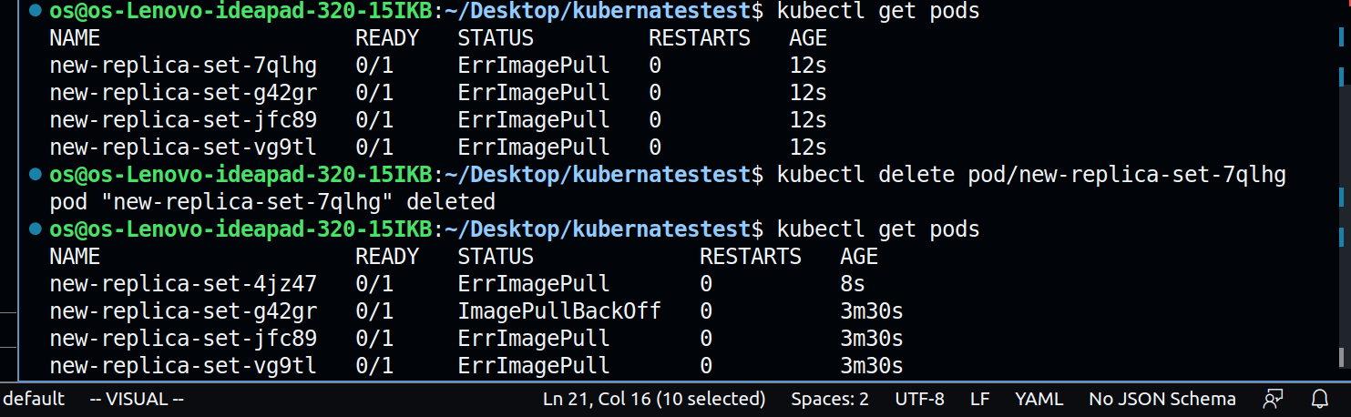

---------------------
7-Why are there still 4 PODs, even after you deleted one?

Beacause replicaset desire state 4

-----------------
8-Create a ReplicaSet using the below yaml

There is an issue with the file, so try to fix it.

apiVersion: v1
kind: ReplicaSet
metadata:
name: replicaset-1
spec:
replicas: 2
selector:
matchLabels:
tier: frontend
template:
metadata:
labels:
tier: frontend
spec:
containers:
- name: nginx
image: nginx

Answer :

the name of the version shoud be apps/v1 instead of v1

